**Experiment - 1.3(a)**

**Student Name: Milan Sharma UID: 23MAI10003**

**Branch: ME – CSE - AIML Section/Group: MAI – 1 (A)**

**Semester: 1st Date of Performance: 29 Aug 2023**

**Subject Name: Python Programming Subject Code: 23 CSH 623**

1. **Aim of the Experiment :**

Write a python program to illustrate the concept of different types of operators.

* Arithmetic operators
* Bitwise operators
* Logical operators
* Membership operators
* Identity operators

1. **Objective of the Experiment :**

To use different kinds of operators in python program

1. **Algorithm/ Steps for Experiment :**

1.        Take two numbers

2.        Apply different operators on the numbers

3.        Print the results

1. **Code for Experiment :**
2. **Arithmetic Operators –**

a = 9

b = 4

add = a + b

sub = a - b

mul = a * b

div1 = a / b

div2 = a // b

mod = a % b

p = a ** b

print( "Addition of numbers : ", add)

print("Subtraction of numbers : ",sub)

print("Multiplication of number : ",mul)

print("Division(float) of number : ",div1)

print("Division(floor) of number : ",div2)

print("Modulo of both number : ",mod)

print("Power : ",p)

1. **Bitwise Operators –**

a = 10

b = 4

print(a & b)

print(a | b)

print(~a)

print(a ^ b)

print(a >> 2)

print(a << 2)

1. **Logical Operators –**

a = True

b = False

print(a and b)

print(a or b)

print(not a)

1. **Membership Operators –**

list1=[1,2,3,4,5]

list2=[6,7,8,9]

for item in list1:

if item in list2:

print("overlapping")

else:

print("not overlapping")

x = 24

y = 20

list = [10, 20, 30, 40, 50 ];

if ( x not in list ):

print("x is NOT present in given list")

else:

print("x is present in given list")

if ( y in list ):

print("y is present in given list")

else:

print("y is NOT present in given list")

1. **Identity Operators –**

x = 5

if (type(x) is int):

print("true")

else:

print("false")

x = 5.2

if (type(x) is not int):

print("true")

else:

print("false")

1. **Result/Output :**
2. **Arithmetic Operators –**

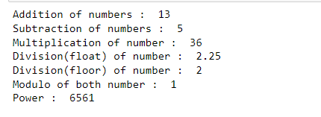

1. **Bitwise Operators –**

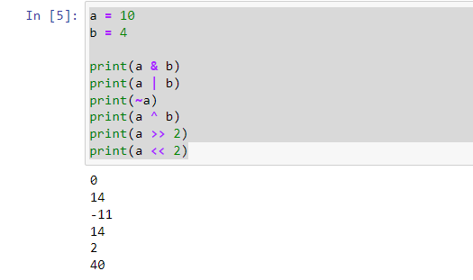

1. **Logical Operators –**

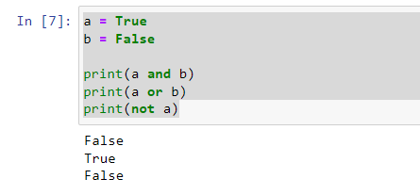

1. **Membership Operators –**

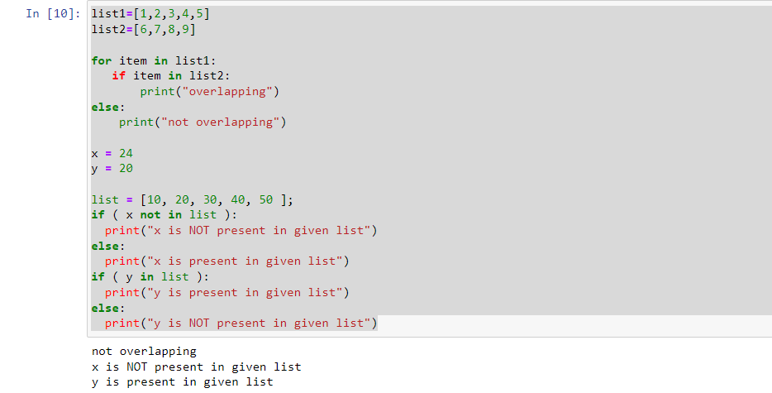

1. **Identity Operators –**

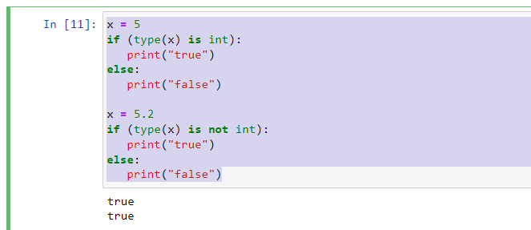

**Learning outcomes (What I have learnt):**

1. Learnt how all the operators work

2. Learnt various different inbuild functions like type() etc

3. Learnt the use of list and operations performed in it